

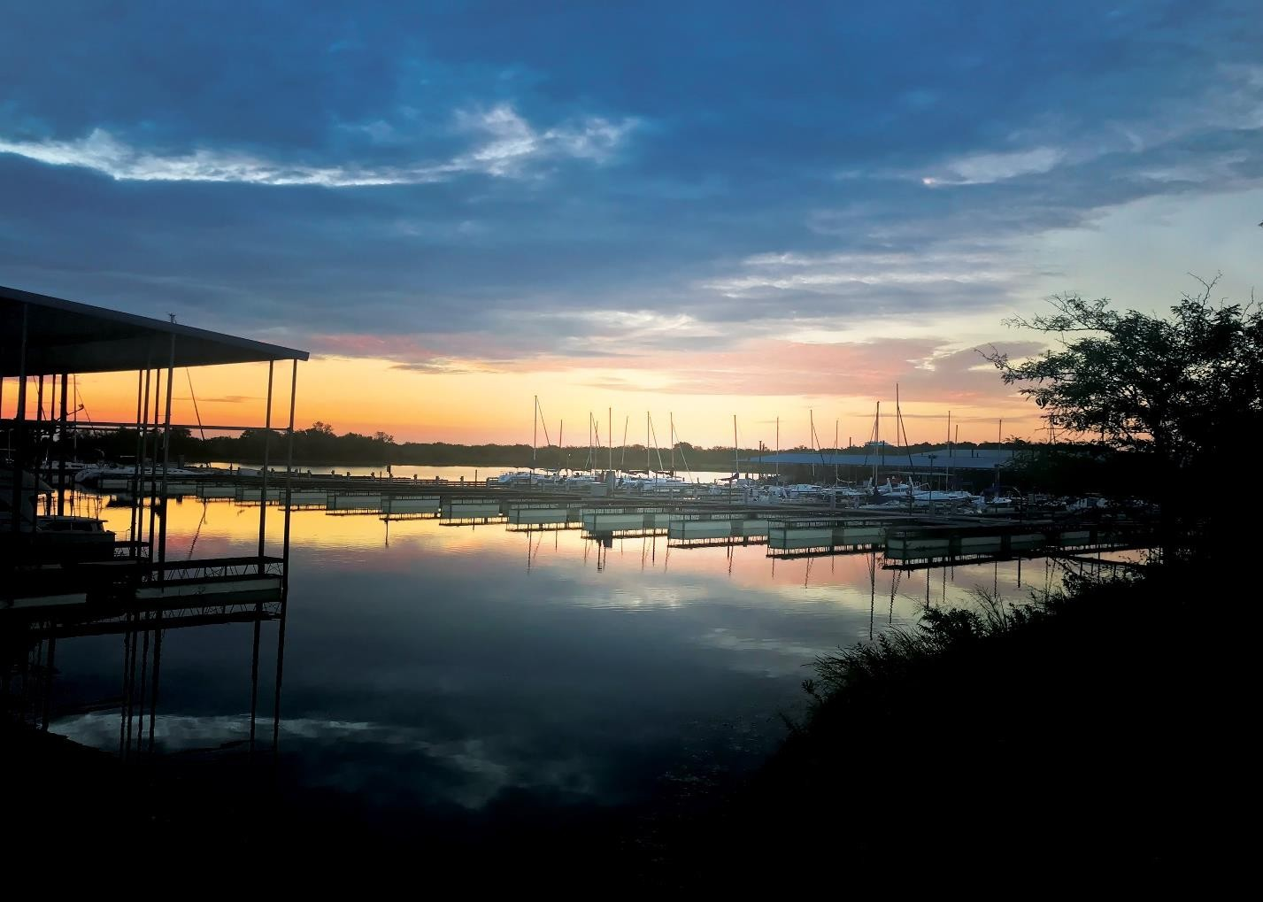 January 2024

Monthly Report

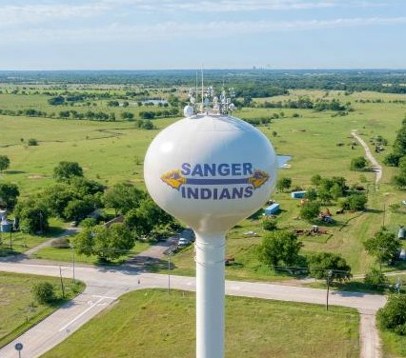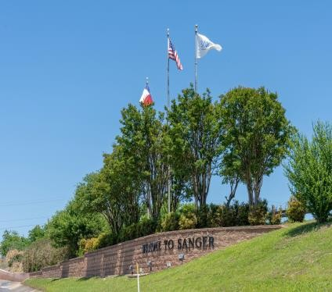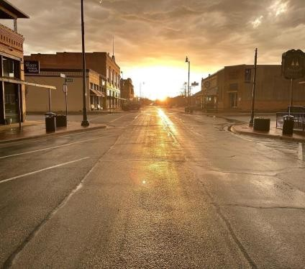

Court

- For the month of January 2024, the Municipal Court filed 79 citations and 96 violations.

- There were 18 requests for deferred disposition.

- 2 requests for a driver safety course.

- There were 10cases successfully closed by deferred disposition and 1 case successfully closed by driver safety course.

- The court closed 36 cases by payment in full or time served.

- 37 warrants issued for the month.
- 30 outstanding warrants transferred to collection agency.
- The total fines, court costs, and other fees collected were $13,416.00 with
$4,403.13 of that being remitted to the State.

Development Service
During the month of January 2024, Development Services had the following permits:

New Residential – 7 Residential Remodel – 0 New Commercial - 0 Commercial Alterations – 4 Miscellaneous- 39 Certificate of Occupancy – 1
Inspections:
New Residential – 112 Residential Remodel – 17 New Commercial - 15 Commercial Alterations – 54 Miscellaneous- 35 Certificate of Occupancy – 3
Code Enforcement:
Cases open | 7
Complaint received | 2
Cases closed | 14
Average # of days to close case | 32
Citations issued | 1
Worker orders issued | 1
Liens filed | 1
Signs pulled | 34
Case violation types
High grass & weeds |  | 0
Trash & debris |  | 6
Parked on an unimproved surface |  | 5
Blocking sidewalk |  | 1
Junked Vehicle |  | 0
Referred to another department |  | 0
Work without a permit |  | 1
Zoning violation |  | 0
Placement of Trash Containers |  | 0
Accessory Building Regulations |  | 0
Dangerous Building |  | 0
Signage maintenance |  | 0

Brush pile pickup program
19 addresses on the pickup list | (38 inspections)
8 piles greater than 4 qu. Yds. | 42%
19 piles removed by Republic
0 pile missed by Republic
0 pile blocked
1 generated by citizens | 5%
1 on line | 100%
0 calling in | 0%
18 generated by Code Enforcement | 95%

10 Code Enforcement hours on this program

Economic Development
During the month of January 2024, the Economic Development Department performed the following:

Administrative Meetings:
- City Council workshop and regular meeting - 01/02/2024
- 4B Board meeting - 01/23/2024
Chamber Events Participation:
- Business Over Breakfast - 01/10/2024
- Ambassador meeting - 01/29/2024
Other Event Participation:
- DFW Commercial Real Estate Forecast Summit – 01/18/2024
Property Enhancement Grant
- 204 Bolivar
- 205 Acker
Total Leads Received (State, Dallas Chamber, Fort Worth Chamber):
- 3 – Governor’s Office of Economic Development & Tourism
- 1 – Denton Regional Chamber
- 1 - Broker
Economic Development Sales Tax Collection for Type A & Type B:
- $78,147 for the month of January
- $297,009 Total YTD
Projects:
- Miracle Field League (4B Project)
- Downtown Park (4B Project)

Electric Department
During the month of January 2024, the Electric Department performed the following:
Disconnected 504 S. 10th Street due to an auto accident.
Replaced broken pole at 2845 View Road. Took down Christmas lights at City Park.
Disconnected the power at the Police Station for generator installation. Audit of progress of Power Standard for I-35 expansion.
Performed Disconnects.
Helped Service Truck with rechecks. Reconnected security lights at Good Guys Steel.
Hung Transformer, hooked up service and installed meter for garage at 4777 FM 455.
Also, during the month of January 2024 the Service Truck performed the following:
Connects – 23
Disconnects – 20 Occupant change – 19 Cutoff – 25
Reinstates – 22 Changed out meters – 1 Re-read – 55
Security Light Disconnected – 1
Solar – 1
Line Locates – 185

Finance
The Finance Division is responsible for all the City's financial, accounting, payroll, and utility billing operations. The department manages the City’s resources through budgeting, purchasing, and reporting. Functions of the department include billing and collecting for all utilities, handling all accounts receivable and payable, preparing payroll for all City employees, paying all City obligations, and preparing the annual budget document.

During January 2024, the Finance and Customer Service Departments staff performed the following departmental functions for the city:
- Accounts Payable - Processed 305 Accounts Payable invoices totaling
$1,446,075
- Purchase Orders - Issued 37 Purchase Orders totaling $414,174
- Payroll - Issued 184 payments to employees totaling $393,338
- Utility Customer Service - Prepared 4,125 Utility bills and Collected 4,091 payments on Utility accounts.
- Financial Reporting – prepared monthly financial statements for City Council and biweekly internal budget reports for City staff.

Emergency Responses

The Sanger Fire Department responded to 150 emergency incidents during the month of January the top four busiest incident types:

Top Four busiest incident Types:

  - 95 Emergency Medical Incident
  - 26 Service calls
  - 12 Good intent
  - 9 False Alarms
EMS Incidents January
  - The busiest time of the day was 10:00-10:59 for the month of January.
  - The busiest day of the week for patient transports was on Monday, with 15 patient transports during the month. We transported 90% of our patient contacts.
  - Average transport time, from the incident scene to receiving facility was 17 minutes and 21 seconds.
  - Average response time, from time of alarm until arriving on scene, for the entire district (city and county) was 7 minutes and 27 seconds for the month of January.
  - Emergency Medical calls accounted for 63.77 % of the total call volume.
  - 68 patients encounter with an average on scene time before transport was 12 minutes and 09 seconds.
  - 75 Patient Contacts for the month of January
    - 41 Patients transported no light and sirens
    - 27 Patients transported with lights and Siren Code 3
    - 5 Patients refused transport
    - 2 subjects refused both treatment and transport

Library

  - January was a month of new beginnings and welcomed change at the library. We debuted a new calendar format and added additional programming to our regular schedule for children, teens and adults!

  - Our adult book club’s January selection was The Devotion of Suspect X by Keigo Higashino. The book is tells the story of Yasuko who lives a quiet life, working in a Tokyo bento shop a good mother to her only child. But when her ex-husband appears at her door without warning one day, her comfortable world is shattered. The book was popular in Japan and the English translation was nominated for the 2012 Edgar Award for Best Novel and the 2012 Barry Award for Best First Novel. We welcome new book club members and book club typically meets on the 3rd Tuesday of the month at 6:30 PM.

  - We brought back an old favorite – Make Your Own Buttons for January’s tween and teen hangout. Teens and tweens and their families were delighted to make their own creations and took home some favorite designs like Taylor Swift and Squishmallows!

  - The library was closed Friday, January 12th for a staff development day. We took the opportunity to discuss the City’s goals and the library’s performance measures, goals and objectives in relation to the City’s goals. Staff great progress in planning programs and events through April and part of May.

  - Adults had a blast with Beth Patton! She showed adults how to make their own no-sew mini quilt. Participants made their own beautiful quilt designs using colorful fabric and no sew fusible backing. We will have a class for children ages 11 and up in March and another for adults in April. We look forward to learning more from Beth!

  - Children and their families created a simple bird feeder for their feathered friends to enjoy out of birdseed, shortening and twine.

  - Our last teen and tween hangout of the month featured an Oreo taste test. It was a hit with 11 teens & tweens, 5 adults and 6 children in

attendance. Tasters used their developed and discerning pallets to rank 17 varieties of Oreos. They ranked each Oreo flavor based on appearance, taste, smell and overall likeability! The original Oreo came out on top.

  - Aaron Evans of Yahweh Pottery class was very kind to sponsor another pottery class for adults. We had a full class! Participants had many beautiful creations, such as mugs, dishes and decorative pieces.

  - Denton County United Way’s VITA Tax assistance for the 2024 tax season kicked off on Saturday, January 27. Free tax preparation is available for households earning up to (not over) $64,000 across Denton County. The VITA program is available on a first come, first served basis Saturdays, 9 AM-12 PM through April 13th. Please visit www.unitedwaydenton.org/VITA for more information.

Monthly Statistics:
  - 1,885 physical items were checked out.
  - 433 digital items were checked out.
  - 46 new cardholders, for a total of 3,381.
  - 1,765 visits to the library.
  - 53 reference questions answered.
  - 77 computer-related questions answered.

Parks, Recreation & Facility Maintenance

Parks:
A new year has finally arrived here in Sanger. Last year was a great time to be a part of this special city, it was full of incredible events such as Freedom Fest, Songwriters Festival, and the Christmas Parade. The Parks staff have been keeping the parks in great condition this winter and are gearing up for the Spring. All Christmas decorations have been taken down and stored away for next winter. We want to thank everyone who helped make Downtown Park look as magical as ever this Christmas for all to enjoy. The Porter Park Pond is still under further maintenance. We thank everyone for their patience.

Facilities:
It’s been a wonderful year for the City of Sanger, we look forward to seeing everyone again in 2024. You can find our facility rental calendars as well as the reservation forms for the Community Center, Historic Church, Ball-fields, and all Pavilions on our website www.sangertexas.org, under the Parks and Recreation tab. In January, we had 14 Community Center rentals, 0 Pavilion rentals, and 7 Church rentals.

Department Staff:
Parks & Recreation Director– Ryan Nolting Recreation Coordinator – Blake Junker Maintenance Worker II – Dean Mason Maintenance Worker I – Levi McManus Maintenance Worker I – Asa Campbell

Planning & Zoning
During the month of January, 2024, Development Services worked numerous different projects.

The Planning and Zoning Board was presented the following cases:
- Lane Ranch – PD Amendment – Recommended Approval
- Farmers Market – SUP – Recommended Approval
- Duck Creek Ridge – Preliminary Plat – Recommended Approval with the condition all comments be satisfied prior to City Council
- Duncan Retail – Preliminary Plat - Recommended Approval with the condition all comments be satisfied prior to City Council

The Zoning Board of Adjustments was presented the following case:
- 2010 Duck Creek – Variance - Side-yard setback - Recommended Approval
The City Council was presented the following case:
- Mallard Estates – Minor Plat - Approved

Staff conducted the following meetings relating to development (this does not include walk-in or front counter meetings with applicants/citizens or phone calls)

- Pre- Application/Construction - 3
- Meetings with Developers/Landowners - 5
- Meetings with Builders/Building Owners - 1
- Organization Meetings (NTCOG, ICC, etc.) - 6
- Internal Meetings – 9
- Training – 2

Police
During the month of January 2024, Officers of the Sanger Police Department responded to a total of 1341 calls for service having an average response time of 3 minutes per call. The department issued a total of 86 traffic violations and 131 warnings.

The Texas Department of Public Safety Uniform Crime Reporting tracks seven classifications of offenses. You will find below a list of those classifications as well as any of those classifications the Department responded to:

Criminal Homicide 0
Forcible Rape 0
Robbery 0
Assault 5
Burglary 3
Larceny/Theft 10 Motor Vehicle Theft 1 Officer Assault 0

DWI/Public Intoxication 8
Criminal Mischief/Vandalism 2
Drug Related 5

Streets
During the month of January 2024, the Street’s Department filled and repaired potholes and prepped for more maintenance to be done on Belz Road.

- Street signs were repaired on Porter Place, Rising Star and Duck Creek.

- Barricades were placed on Duck Creek leading up to tree limb cutting and removed once the job was completed.

- Maintenance around the shop, including vehicles, was done in preparation for freezing temperatures.

Water
During the month of January 2024, there were 3,398 active water connections and 3,375 active sewer connections.

- Cleared 5 sewer lateral lines
- Installed 74 new water meters, 288 water and sewer service orders.
- Visually read 678 water meters that were not read by the mobile collector.
- 2 water mains repaired and 4 water service line repairs.
- C&G Electric installed a new micro switch on Pump 1 at Utility Road Wellsite

